This is the first paper on Series 4 of the Open Source Malaria Consortium. For background, files, major discussion etc go to the [Github repository](https://github.com/OpenSourceMalaria/OSMSeries4Paper1).

**A Potent, *in vivo* Active Antimalarial Series Based on a Triazolopyrazine Core: Open Source Malaria Series 4**

Alice Motion,1 Edwin G. Tse,1 Thomas Macdonald,1 Jake Baum2, Michael J. Delves2, Stephan Meister, Ho Leung Ng3, Peter J. Rutledge,1 Christopher Southan, Chris Swain, Chase C. SmithZ, Daisy J. KimZ, Kenneth LoweZ, Kimberly LoweZ, Jessica HaugerZ, Benjamin SedzroZ, Nkengafeh AsongZ, Fernando GalvanZ, Fernando Sánchez-Román Terán, Anthony Sama&, Patrick Thompson, Joanna Ubels,1 Paul Willis, Anubhav Srivastava#, Darren Creek#, Elizabeth Winzeler, Matthew H. Todd1*

1. School of Chemistry, The University of Sydney, NSW 2006, Australia

2. Department of Life Sciences, Imperial College London, Exhibition Road, South Kensington, London, SW72AZ, UK.

X. Department of Pediatrics, Pharmacology & Drug Development, University of California San Diego, 9500 Gilman Drive, La Jolla, California 92093, United States

X. Medicines for Malaria Venture, PO Box 1826, 20 rte de Pre-Bois, 1215 Geneva 15, Switzerland

X. IUPHAR/BPS Guide to PHARMACOLOGY, Centre for Integrative Physiology, School of Biomedical Sciences, University of Edinburgh, Edinburgh, EH8 9XD, U.K.

X. Cambridge MedChem Consulting, 8 Mangers Lane, Duxford, Cambridge CB22 4RN, U.K.

Z. School of Pharmacy (Worcester/Manchester), MCPHS University, 19 Foster Street, Worcester, MA 01608, USA.

X. School of Chemistry, The University of Edinburgh, Joseph Black Building, West Mains Road, Edinburgh EH9 3JJ, U.K.

3. Department of Biochemistry & Molecular Biophysics, Kansas State University, 1711 Claflin Rd., 141 Chalmers Hall. Manhattan, KS 66506, United States.

# Monash Institute of Pharmaceutical Sciences, Monash University, Parkville, Melbourne, Victoria 3055, Australia

X. School of Pharmacy, University College London, London WC1N 1AX, UK

*[matthew.todd@](mailto:matthew.todd@sydney.edu.au)ucl.ac.uk

# &[asamawsfl@protonmail.com](mailto:asamawsfl@protonmail.com)

# **Abstract**

We report an antimalarial series possessing several highly desirable attributes, including high potency and low toxicity in an *in vivo* mouse model of malaria. [Describe chemical novelty The most potent compound in this series has potency X nM in assay Y. The mechanism of action involves inhibition of a sodium ion pump known as PfATP4. And relative superiority to other antimalarial drug leads in the literature] Originating from a pharmaceutical company, and developed further by a contract research organisation, the series was optimised by the Open Source Malaria consortium that has involved inputs from ca. X participants, and therefore remains open for further investigation or commercial development by anyone.

# 

# **Graphical Abstract**

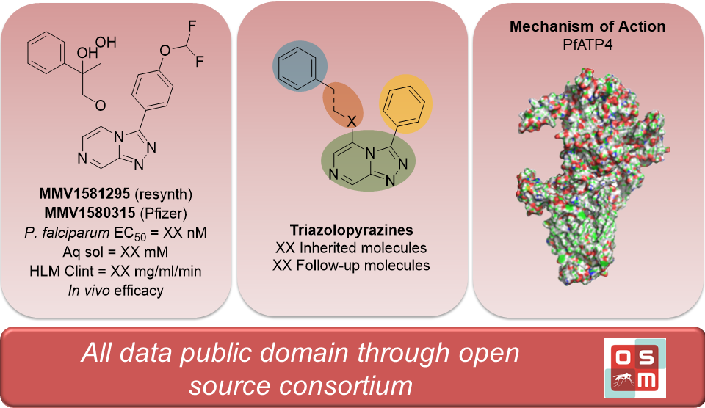

# Introduction

Malaria remains one of the top causes of human death annually, and some of the hardest hit areas are well below the poverty line (World Malaria Report 2019). Alongside poverty, growing resistance to antimalarial drugs pushes the global burden of malaria even further. Resistance to all clinically deployed antimalarial drugs has been reported, including the most recently developed artemisinin derivatives (Ashley 2014, DOI: 10.1056/NEJMoa1314981; Dondorp 2017, DOI: 10.1016/j.pt.2017.01.004). Further growth in artemisinin and multi-drug resistance threatens the global efforts to control malaria. To counter drug resistant malaria, new drugs are needed that have novel mechanisms of action. (Tse 2019, DOI: 10.1186/s12936-019-2724-z)

In order to address the need for new malaria therapeutics, Medicines for Malaria Venture (MMV) partnered with Pfizer to undertake a high-throughput screen (HTS) of 160,000 compounds in Pfizer’s chemical library. Of these (which remain unpublished) a class of triazolopyrazines emerged as a promising antimalarial series. Further development by MMV, first in collaboration with Pfizer, and subsequently with a contract research organization (TGC Lifesciences) resulted in two compounds, **MMV639565** and **MMV669844**, which rapidly cleared parasitemia in a mouse efficacy model of *P. falciparum infection* with an EC90 of 6.3 mg/kg (**Fig X**).

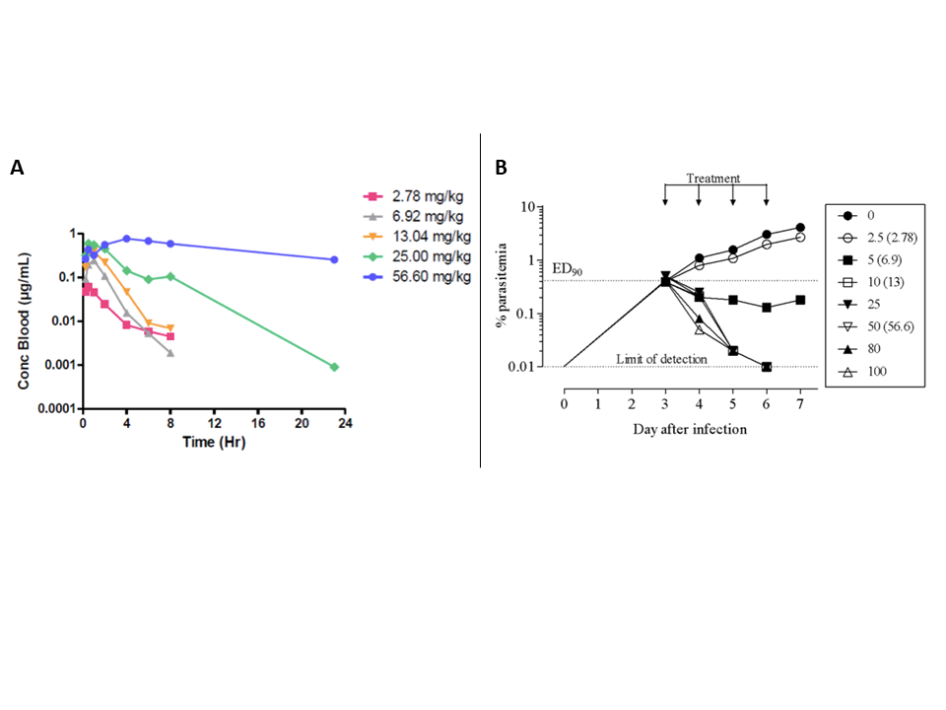

**Figure X.** A) Blood concentration over time and B) *in vivo* efficacy of **MMV639565**. Compound was administered orally, qd for four days at the doses indicated in the legend. Numbers in brackets represent dose (mg/kg) corrected according to quality control of formulation.

These results and other materials, including potency data on just over 100 compounds and a summary report of the series development to date, were then passed to the Open Source Malaria consortium which placed the materials in the public domain, to act as the starting point of a lead optimisation project with the aim of improving compounds’ solubility (≥100 μM) while maintaining potency (<10 nM) and low rates of metabolic clearance (<https://www.mmv.org/research-development/information-scientists>). The aim in making the project public was to investigate whether an open, unrestricted collaboration could progress a medicinal chemistry series during the lead optimisation phase, which can be a more resource intensive phase of drug discovery and development than projects in early stage medicinal chemistry (Williamson 2016, DOI: 10.1021/acscentsci.6b00086), screening (Antonova-Koch 2018, DOI: 10.1126/science.aat9446) or compound sharing (Dennis 2018, DOI: 10.1038/s41598-018-26819-1; Spangenberg 2013, DOI: 10.1371/journal.pone.0062906). We present here the combined knowledge to date on this series, which demonstrate the significant potential of these public domain compounds for the treatment of blood stage malaria infections and evidence of their mechanism of action.

# 

# **Results and Discussion**

## Synthesis

The synthetic protocols for any compound in this paper may be found in full in the SI; in addition the complete synthetic details of *every experiment* may be found in the relevant electronic laboratory notebooks (ELNs). The most commonly used synthetic approaches are shown below; synthetic routes to analogs outside the scope of these routes, such as alternative cores or reverse amides, are presented in **Schemes SX-SX**.

The Series 4 triazolopyrazines can, most broadly, be classified into two sub-classes of compounds: those with an ether linker (or other heteroatom) in the 5-position, and those with an amide linker. The synthesis of the former may be achieved by initial displacement of a chlorine atom from 2,6-dichloropyrazine with hydrazine hydrate to give the hydrazine intermediate (**A, Scheme X**). Condensation with the appropriate aldehyde and subsequent oxidative cyclisation using (diacetoxyiodo)benzene affords the cyclised triazolopyrazine core. The final products were obtained upon displacement of the 5-position chlorine atom with the appropriate nucleophile (either synthesised or commercially available). In the case of the amide-linked compounds, the linker was first installed *via* T3P mediated amide coupling with 6-chloropyrazine-2-carboxylic acid and the appropriate amine (**B, Scheme X**). The subsequent steps to form the triazolopyrazine core were performed in the same manner as for the ether-linked compounds. In both cases, the synthetic procedures used were robust and applicable to multi-gram scale. Focussed subsets of Series 4 compounds have been previously reported elsewhere (Ref to JOC and JMC papers).

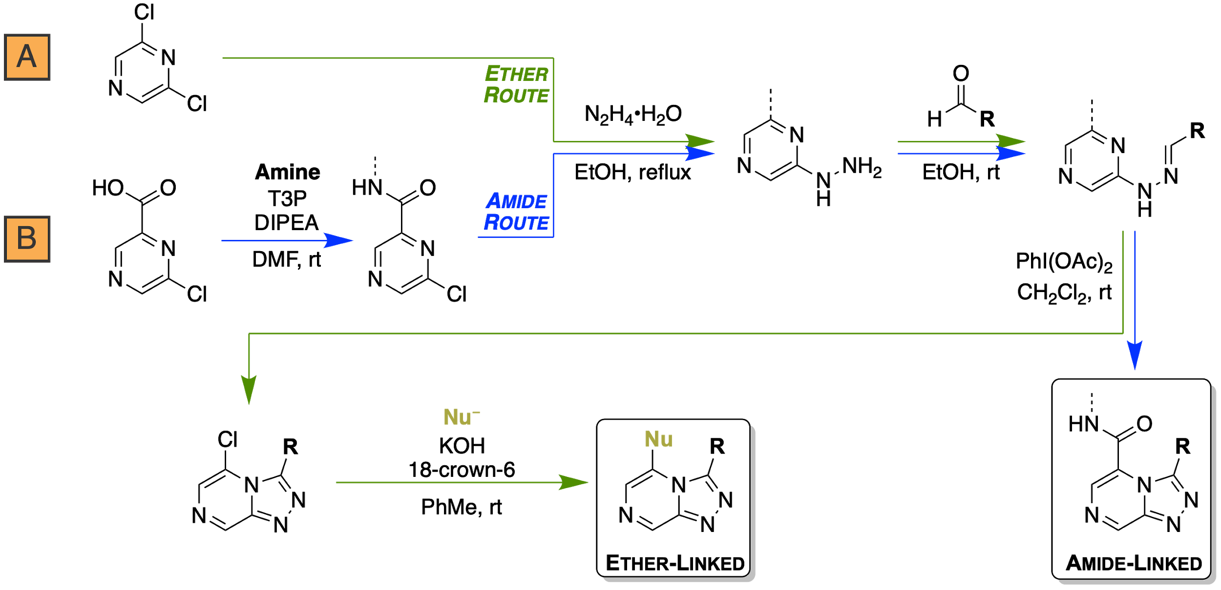

**Scheme X.** General synthetic route to the 5-substituted ether- and amide-linked triazolopyrazines. *Reagents and reaction conditions*: *a*) Hydrazine hydrate, *ca*. 85% crude. *b*) RCHO, AcOH, *ca*. 100% crude. *c*) PIDA, CH2Cl2, 40-83%. *d*) Nucleophile (Nu) and *either*: i)KOH, 18-crown-6, toluene; ii) KO*t*-Bu, dioxane; or ii) NaH, DMF. *ca.* 50%.

## Structure-activity relationships

To investigate further the established structure-activity relationships (SAR) from the inherited data, the OSM consortium sought to explore modifications designed to help improve the aqueous solubility and metabolic stability of the series. Key SAR are presented in **Figure X** (see SI for full SAR). As a result of this open source project having many contributors worldwide, varying sources of *in vitro* assays were used which evaluated the compounds against either the NF54 or 3D7 strain of *P. falciparum*; suitable controls were used throughout to ensure data between assays (*e.g.*, inherited *vs.* generated data) could be compared. Both strains are comparable, with the difference begin that NF54 is sensitive to all known drugs, while 3D7 is a clone of the NF54 strain and is known to produce fewer gametocytes in *in vitro* cultures.[10.1038/nprot.2016.096] Any cLogP values were calculated using DataWarrior.

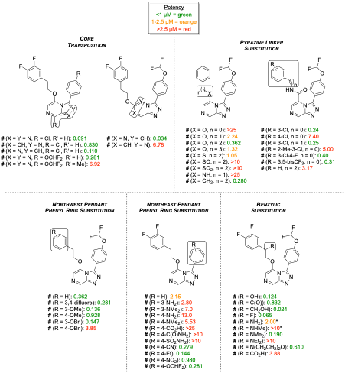

**Figure X.** Key compounds designed to investigate *in vitro* potency, aqueous solubility and metabolic stability. *Compounds presented as enantiopure.

The inherited data had mostly explored variations in the heterocyclic core and chain transposition, with the results suggesting further exploration in the variation of the pendant groups would provide the most fruitful compounds. The importance of the triazolopyrazine core was established *via* a number of analogues. A loss in potency was observed upon systematic replacement of the core triazole nitrogens with –CH groups (**X** and **X**). Additional substitution at the 8-position with a methyl group (**X**) also led to a significant loss in activity. Transposition of the ether side chain from the 5-position to the 6-position (**X**) was well tolerated, however subsequent transposition of the pyrazine nitrogen (**X**) led to a large reduction in potency. Transposition of the ether side chain to the 8-position has also been shown to result in inactive compounds [insert ref to tele-sub paper when available].

The identity and length of the linker unit between the 5-position aryl group and the triazolopyrazine core proved influential on antimalarial activity. An ether linker with two methylene units between it and the pendant phenyl ring (**X**) was ideal, with longer or shorter chain lengths resulting in reduced activity (Tse 2020, DOI: 10.1021/acs.jmedchem.0c00746). A significant loss in potency was seen upon replacement of the ether linker with a thioether (**X**), sulfoxide (**X**), sulfone (**X**) or amine (**X**) linker; other heterocyclic or reverse amide linkers were also inactive (**Table SX**). Interestingly, exchanging the heteroatom with an additional methylene group (**X**) was well tolerated; however, this change was accompanied by an increase in cLogP (from 3.15 to 3.73). In certain cases, an amide linker was shown to be beneficial to *in vitro* activity. The analogues containing *meta*-substituted phenyl rings (**X** and **X**) showed good activities that were comparable to the ether-linked compound **X**. Compounds with *ortho*- (**X**), *para*- (**X**) or no (**X**) substitution were significantly less active. Amide compounds derived from secondary amines (**Table SX**) were also inactive. While certain amide compounds showed good activity, early exploration of hERG binding (*vide infra*) suggested the amide linker introduced a liability. As a result, the amide sub-series was de-prioritised.

As a general trend throughout the series as a whole, replacement of the northwest pendant phenyl ring in **X** with a 3,4-difluorophenyl substitution pattern (**X**) resulted in increased activity. *Meta*-substitution alone was well tolerated as seen with the methyl (**X**) and benzyl (**X**) ethers, while *para*-substitution was much less favourable (as for **X** and **X**). As part of a separate investigation, a series of compounds in which the pendant phenyl ring was replaced with saturated heterocycles and hydrocarbon cages were made in an attempt to improve solubility and metabolic stability *via* deplanarisation and dearomatisation. Such changes generally resulted in reduced efficacy, with a small number of notable exceptions (Tse 2020, DOI: 10.1021/acs.jmedchem.0c00746).

The triazole 3-position substituent (northeast pendant phenyl) was seen to be highly sensitive to substitution. Generally, *meta*-substituted phenyl rings (**X** and **X**) were tolerated worse than *para*-substituted phenyl rings. Substitution with amines (**X** and **X**) was poorly tolerated, as was carboxylic acid (**X**), amide (**X**) and sulfonamide (**X**) substitution. Despite evidence that on related scaffolds, a *para*-methylsulfone substituent on the phenyl ring would result in highly potent compounds (Manach et al 2014, DOI: 10.1021/jm500098s and Manach et al 2015, DOI: 10.1021/acs.jmedchem.5b01605), these analogs were inactive in this series (**Table SX**). In keeping with the goal of improving metabolic clearance and solubility, saturated and unsaturated heterocycles were assayed in this position. Although these compounds usually resulted in lower clogP, they were generally inactive (**Table SX**).

Finally, benzylic substituted analogues were designed to mitigate a potential metabolic liability at this position and improve solubility. These modifications were overall beneficial, with many compounds showing sub-micromolar activity. The most notable benzylic substitutions are with alcohols (**X** and **X**), fluorine (**X**) and dimethylamine (**X**), which all showed improved activity over the compound with the unsubstituted ethylene linker (**X**). In addition, the installation of alcohols translated to improved clogP and LLE >4 (**Table SX**). On the other hand, other modifications were clearly detrimental to potency, such as the installation of a carboxylic acid at this position (**X**).

In summary, a number of key motifs are required to maintain activity. The triazolopyrazine core is essential for activity with any modification resulting in a loss of *P. falciparum* activity. A pendant aromatic ring at the 5-position of the core is required for activity, with the 3,4-difluoro being the preferred substitution pattern. *Para*-substituted aromatic rings were most beneficial for activity at the 3-position. The linker tolerated a number of modifications, with primary alcohols at the benzylic position providing an improvement in both potency and clogP.

*hERG Liability*

Two inherited compounds (**MMV669844** and **MMV670944**) had been evaluated for hERG activity, with both shown relatively high levels of hERG affinity. Upon further investigation with a number of additional compounds, the amide-linked compounds were found to provide higher levels of hERG binding than the ether-linked compounds.  
  
*Metabolism and solubility.*

A number of key compounds from the SAR investigations were evaluated for their metabolic and physicochemical properties (Table X). Many of these compounds showed improved clearance and solubility over **MMV897698**, showing that it is possible to meet the PK/PD MMV progression criteria in this series. Amide **MMV670944** stands out with particularly high half-life and solubility; in addition, compounds containing benzylic alcohols (**MMV688896**, **MMV672687**, and **MMV693155**) are promising.

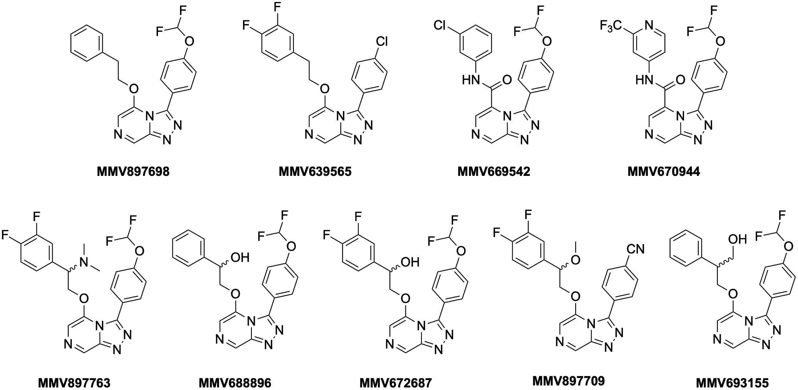

|  |  |  |  |  |  |  |  |
| --- | --- | --- | --- | --- | --- | --- | --- |
| ***Entry*** | ***Compound*** | ***P. falciparum EC50 (uM)*** | ***CLint (uL/min/mg)*** | | ***T1/2 (min)*** | | ***Solubility pH 6.5 (ug/mL)*** |
| ***HLM*** | ***Rodent LM*** | ***HLM*** | ***Rodent LM*** |
| **1** | **MMV897698** | 0.362 | 66 | 187a | 26 | 9a | 6.3 – 12.5 |
| **2** | **MMV639565** | 0.143 | 33 | 193b | 53 | 9b | 3.1 – 6.3 |
| **3** | **MMV669542** | 0.242 | 72 | 290a | 13.6 | 6a | <2.5 (pH 7.4) |
| **4** | **MMV670944** | 0.451 | 21 | 21b | 95 | 81b | 50 – 100 |
| **5** | **MMV897763** | 0.190 | 264 | 478b | 7 | 4b | 6.3 – 12.5 |
| **6** | **MMV688896** | 0.360 | 7 | 278b | 246 | 6b | 25 – 50 |
| **7** | **MMV672687** | 0.070 | 38 | 170b | 45 | 10b | 12.5 – 25 |
| **8** | **MMV897709** | 0.146 | 47 | 159b | 37 | 11b | 12.5 – 25 |
| **9** | **MMV693155** | 0.134 | 24 | 160a | 73 | 11a | 12.5 – 25 |

**Table X**. Clearance and solubility data for selected analogs. aRat liver microsomes. bMouse liver microsomes.

In a further effort to understand how the triazolopyrazines were being metabolised, metabolite ID studies were undertaken on three compounds (**File SX**). Oxidation of the triazolopyrazine core was consistently observed, in addition to side chain-specific transformations such as *O*-dealkylation of ethers. It was undetermined whether this oxidation was due to traditional CYP enzymes or whether aldehyde oxidases (AOs) were involved, and further investigation of potential AO metabolism of the series was then undertaken by comparing the half life in human liver cytosol of compounds of interest to that of known AO substrates (**File SX**). From this work, it was observed that compounds containing benzylic alcohols, such as **MMV688896** or **MMV693155** (**Table X**), were relatively stable to AO metabolism, while amides were metabolised quickly. Further, the imidazolopyridine core was identified as a metabolic risk compared to the triazolopyrazine. Based on these studies, combined with the hERG data (above), the triazolopyrazine core was retained moving forward, but the amide side chains were deprioritised despite initially promising clearance and solubility.

Finally, select compounds were investigated as candidates for late-stage biofunctionalization using liver microsomes (**Fig. X**). In short, (procedure in 1 sentence, i.e. what was done, and that the compounds were characterised and evaluated). The metabolites generated from the representative amide compounds (**MMV670246** and **MMV670944)** were found to be oxidised on the nitrogen heterocycles, both of which led to reduced efficacy *in vitro*. Metabolism of two compounds possessing benzylic hydroxy groups (**MMV688896** and **MMV672687**) led to the less desirable benzylic ketone products (*vide supra*). Surprisingly, while the metabolite resulting from the benzylic primary alcohol compound **MMV693155** was found to be hydroxylated at the benzylic position (**X**) similar to the previous compounds, this metabolite was shown to be significantly more potent than the parent compound.

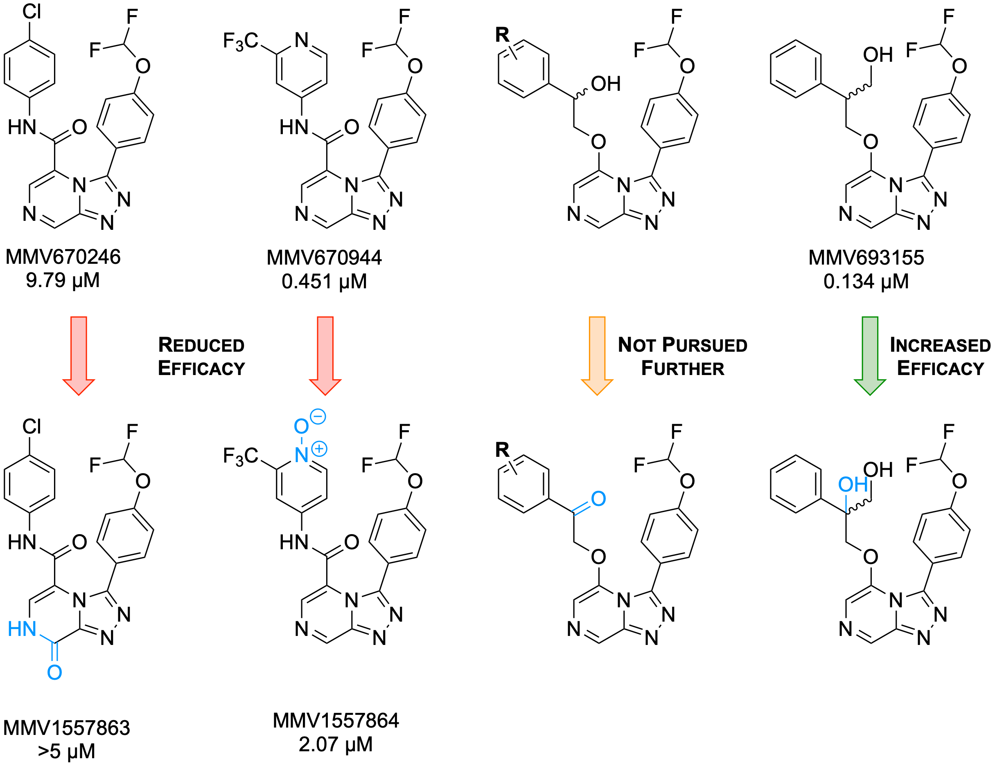

**Figure X.** Compounds of interest and isolated metabolites, with major structural changes highlighted in blue.

Comments about whether blocking metabolic sites is working (not really?).

Another strategy for improving clearance is to make the compounds more soluble. (REF from Ed’s thesis?). Is there an experimental correlation here between sol and clearance (p450s are lipophilic)?

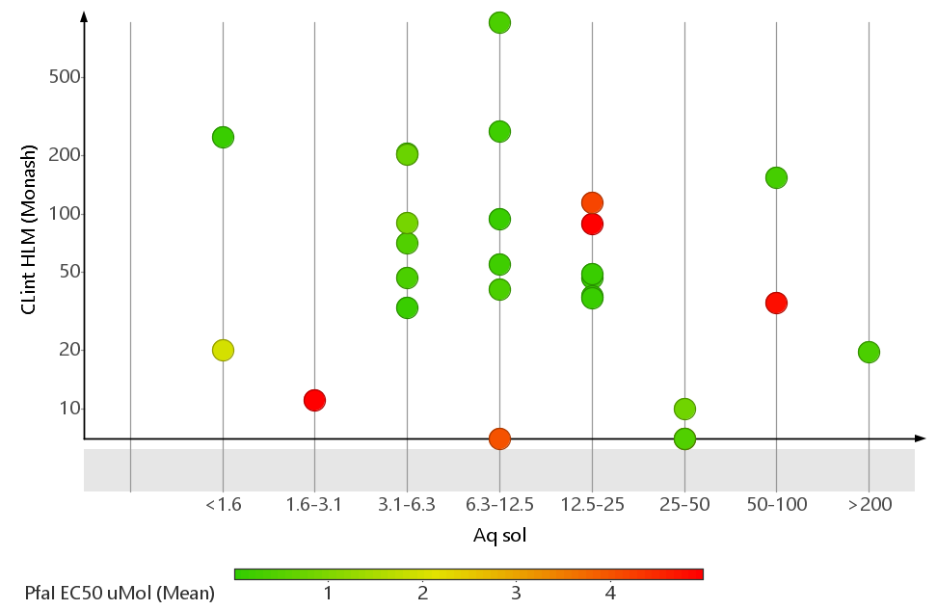

## 

## Further development of OHOH compound.

The diol **MMV1580315** identified from metabolite ID studies of MMV693155 was of great interest due to its high potency (**Figure X**) and presumably improved metabolic stability. Laboratory synthesis of this compound was undertaken and proceeded according to **Scheme X**. Acid catalyzed protection of **X** to give the cyclic acetal **X**, followed by oxidative cleavage of the amino alcohol afforded the ketone **X**. Subsequent Grignard reaction of **X** with phenylmagnesium bromide gave the corresponding tertiary alcohol **X**. Deprotection to give the triol **X**, and subsequent re-protection led to the desired coupling partner with a free secondary alcohol (**X**). Nucleophilic displacement with the triazolopyrazine core **X** gave the protected compound **X**, which was ultimately deprotected under acidic conditions to give the final laboratory synthesised compound **X** (a.k.a. the OHOH compound). Two further derivatives (**X** and **X**) containing substituted phenyl rings (either 3,4-difluoro or 4-NMe2, respectively) were synthesised with the corresponding phenyl substituted Grignard reagents synthesised *in situ*.

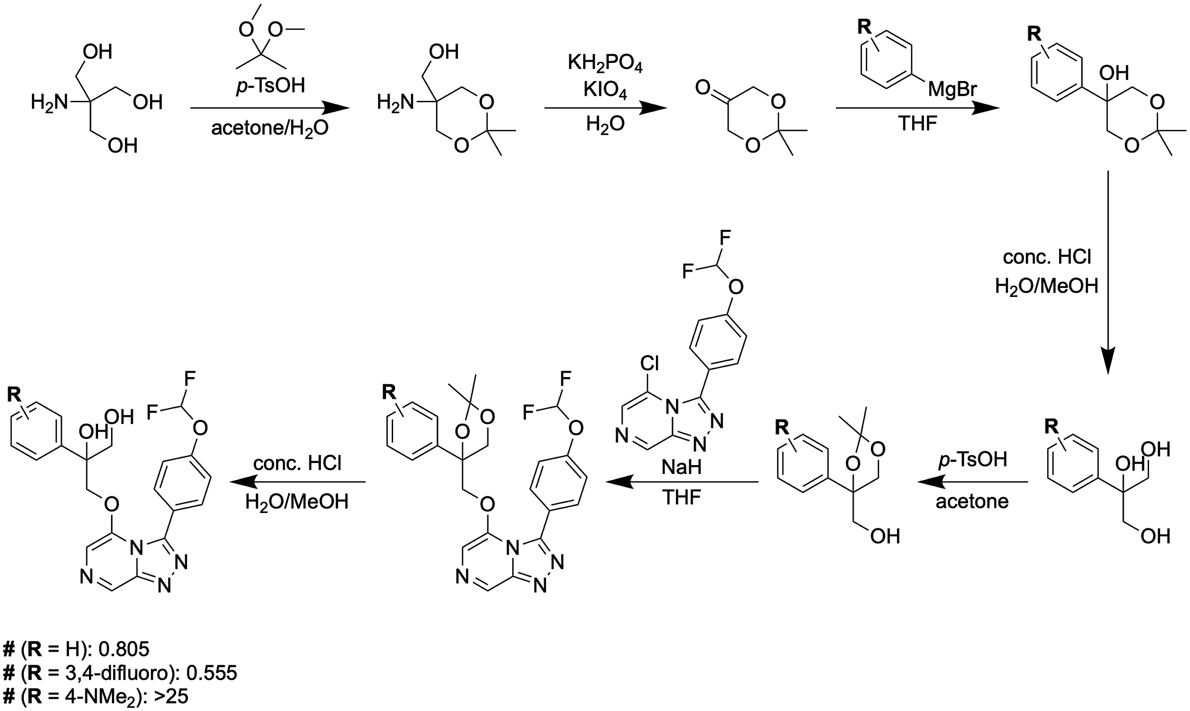

**Figure X.** Synthesis of OHOH derivatives. *Reagents and reaction conditions*

The potency of several OHOH derivatives and clearance and solubility data from **MMV1581295** are shown in **Table X**. The resynthesized OHOH compound **MMV1581295** (**2**) was not as potent as the biosynthesized **1** derived from metabolite ID studies, despite identical NMR and LCMS spectra (**Figure SX**). The 3,4-difluoro analog **3** was more potent than its unsubstituted counterpart, consistent with established SAR, while the *para*-dimethylaniline analog **4** was inactive. However, **2** showed promising ADME data, with high solubility, excellent HLM clearance, and moderate RLM and MLM clearance.

|  |  |  |  |  |  |  |
| --- | --- | --- | --- | --- | --- | --- |
|  | | | | | | |
| **Entry** | **ID** | ***P. falciparum* EC50 (μM)** | **Aqueous Solubility (μg/mL)** | **Clint/T1/2** | | |
| **HLM** | **RLM** | **MLM** |
| 1 | MMV1580315  OSM-S-541 | 0.009 |  |  |  |  |
| 2 | MMV1581295  OSM-S-556 | 0.805 | 50-100 | 15/116 | 45/38 | 42/41 |
| 3 | MMV1581298  OSM-S-560 | 0.555 |  |  |  |  |
| 4 | MMV1581305  OSM-S-568 | >25 |  |  |  |  |

**Table X.** Biological data for OHOH derivatives. Dundee *P. fal* assay and Monash ADME data.

## Mechanism of action.

[Other antiprotozoals with TP or closely related cores, and evidence that these are distinct from S4]

[ref to predictive paper?, find a place to insert]

Preliminary investigation of the mechanism of action of Series 4 compounds points to PfATP4 as the target. Several studies have demonstrated that PfATP4 is a sodium efflux transporter that is required to maintain sodium homeostasis in the malaria parasite, and that inhibition of this protein results in an accumulation of sodium ions which leads to parasite death (Spillman 2013, DOI: 10.1016/j.chom.2012.12.006; Spillman 2015, DOI: 10.1016/j.ijpddr.2015.07.001). Induced resistance studies of a number of diverse chemotypes, some of which are shown in **Fig. X**, implicate PfATP4 as the target (Lehane 2014, DOI: 10.1111/mmi.12765; Spillman 2015, DOI: 10.1016/j.ijpddr.2015.07.001). For Series 4 compounds, activity in an *in vitro* assay for this target (Rosling 2018, DOI: 10.1074/jbc.RA118.003640) [correlates with blood stage antiparasitic activity](https://github.com/OpenSourceMalaria/Series4/wiki/Mechanism-of-Action%3A-Possible-PfATP4-Activity-Deduced-from-Parasite-Ion-Regulation-Assays) (**Table SX**), and cross resistance is observed with known PfATP4-resistant mutants. [Chase Smith/Broad Experiments](https://github.com/OpenSourceMalaria/Series4/issues/16), [Kirk experiments](http://malaria.ourexperiment.org/biological_data/11448/post.html)

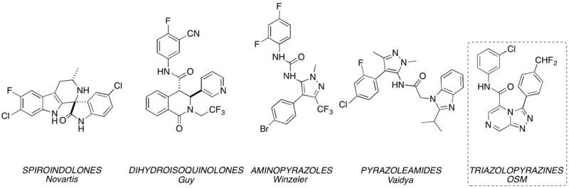

**Figure X.** Putative PfATP4 inhibitors.

The mode of action was further investigated using an unbiased metabolomics approach, which has previously been shown to reveal both novel and established modes of action of antimalarials (Creek 2016, DOI: 10.1128/AAC.01226-16). The active antimalarial **OSM-S-313**, and the inactive analogue **OSM-S-291**, were incubated with trophozoite stage *P. falciparum* parasites for five hours alongside reference compounds including atovaquone (ATV), chloroquine (CQ), dihydroartemisinin (DHA) and three PfATP4 inhibitors, **MMV00073**, **MMV397264** and **MMV390482**. [Show that OSM-S-313 is different from MMV00073, MMV397264 and MMV390482]. Metabolomics analysis of cell pellets and spent media allowed reproducible detection of diverse metabolites from a range of metabolic pathways, with the most significant **OSM-S-313**-induced perturbations observed within peptide, lipid and energy metabolism, suggesting a specific impact on parasite metabolism (**Fig. Metab_S1**).

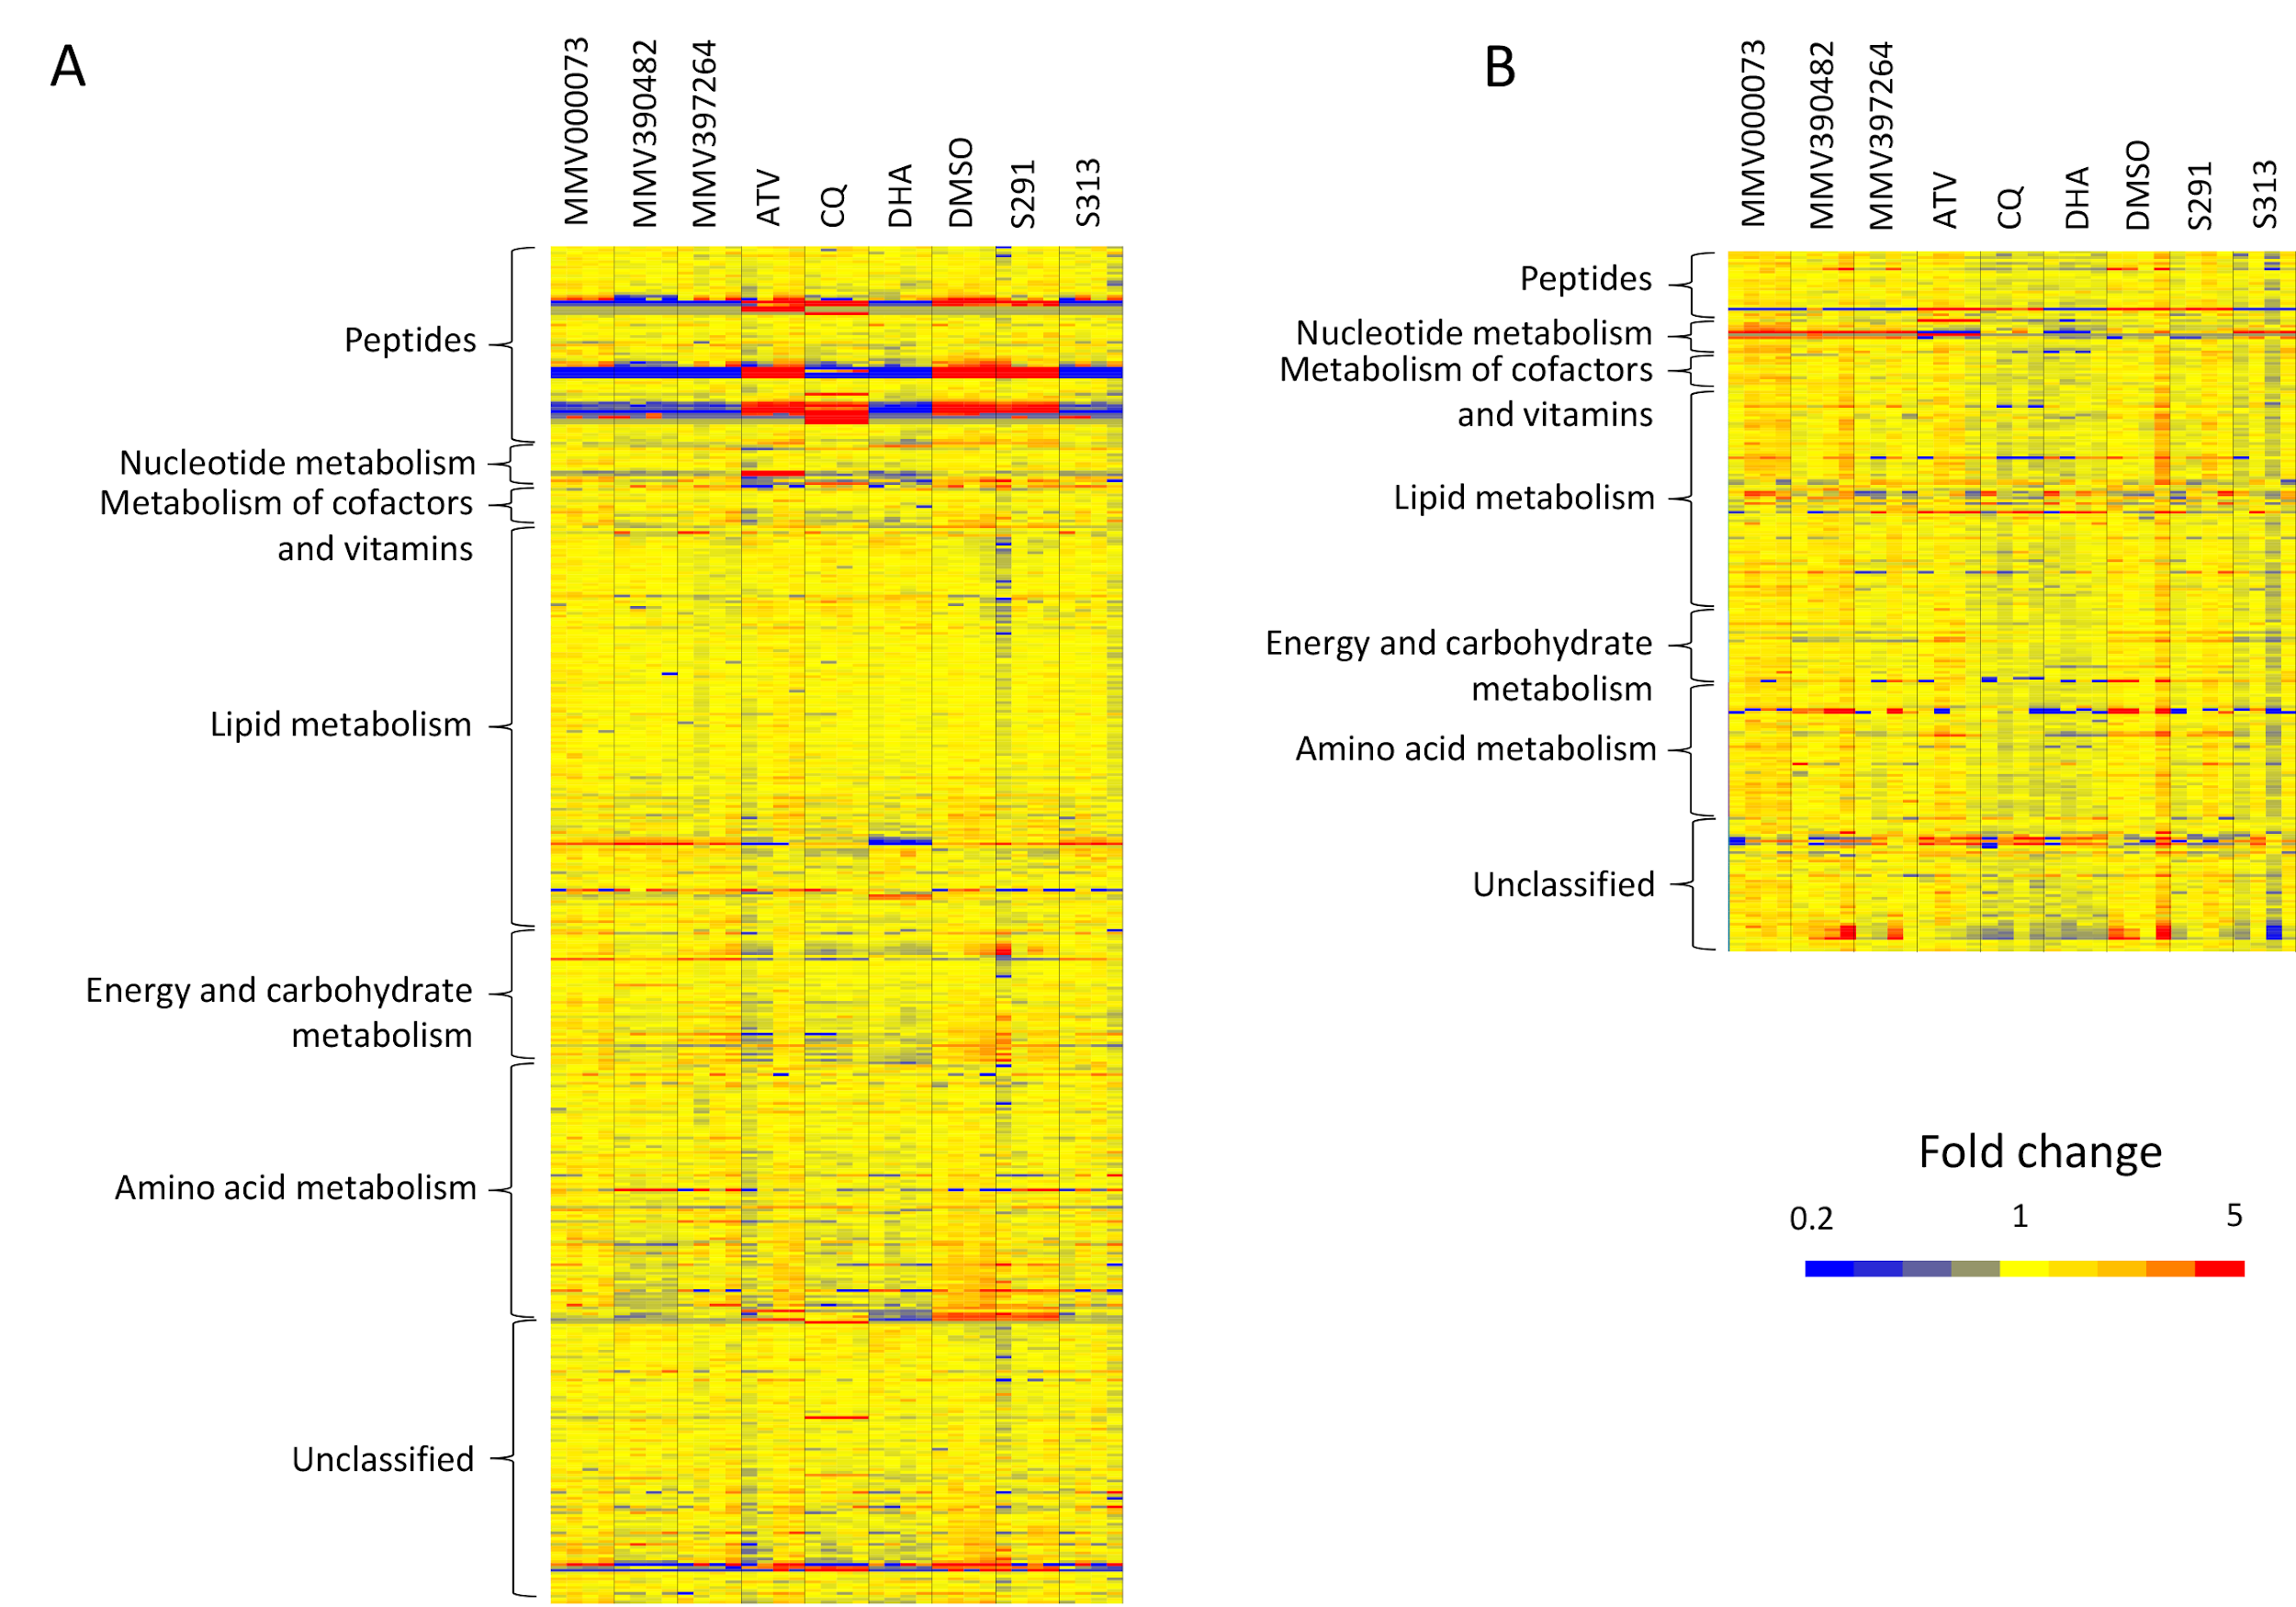

**Fig Metab_S1** Heatmap of putative metabolite (y-axis) abundances in all samples treated with OSM-S-313, OSM-S-291, dihydroartemisinin (DHA), chloroquine (CQ), atovaquone (ATV), PfATP4 inhibitors (MMV00073, MMV397264 and MMV390482) and vehicle control (DMSO) (x-axis: replicates are adjacent and different treatments are separated by vertical black lines). Yellow features indicate no significant perturbation of metabolite levels relative to DMSO controls. Increased and decreased metabolite levels in treated cells are represented by red and blue, respectively. (A) Heatmap of putative metabolite features identified in cell pellets under different treatments. (B) Heatmap of putative metabolite features identified in spent media under different treatments. **(This is a supplementary figure and will not appear in the main text. This is a low resolution figure. High res image for the figure will be submitted for publication)**

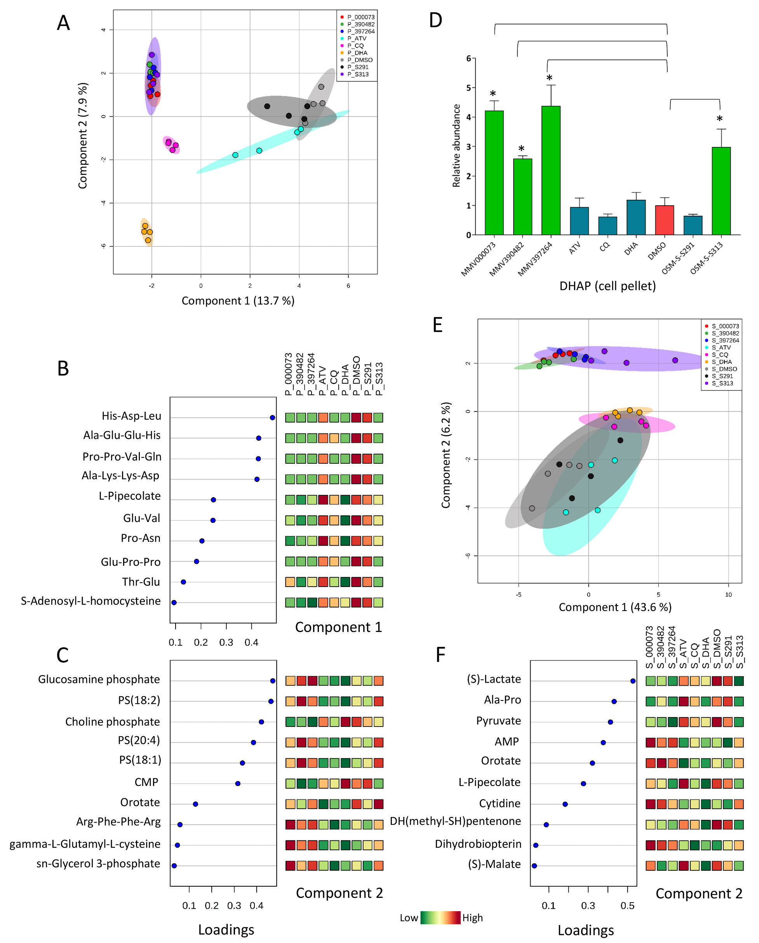

**Fig Metab_1.** (A) Multivariate sparse-PLSDA analysis of levels of all putatively identified metabolites from P. falciparum-infected red blood cell pellets treated with OSM-S-313, OSM-S-291, dihydroartemisinin (DHA), chloroquine (CQ), atovaquone (ATV), PfATP4 inhibitors (MMV00073, MMV397264 and MMV390482) and vehicle control (DMSO). (B/C) Sparse-PLSDA loadings of metabolite features responsible for the distribution of sample groups across components 1 (B) and 2 (C) in panel A and their mean relative abundance. (D) Relative abundance of dihydroxyacetone phosphate (DHAP) in all treatment groups (mean peak intensity + standard deviation. N = 4, *p-value < 0.05). (E) Multivariate sparse-PLSDA analysis of levels of all putatively identified metabolites from spent media under different treatment conditions. (F) Loadings of metabolite features responsible for the distribution of sample groups across component 2 in panel E and their mean relative abundance. Abbreviations: PS: phosphatidylserine, CMP: cytidine monophosphate, AMP: adenosine monophosphate. **(This is a low resolution figure. High res image for the figure will be submitted for publication.)**

A multivariate sparse-PLSDA analysis of cell pellet samples revealed that the primary metabolic impact of **OSM-S-313** treatment was consistent with the perturbations observed for the three reference PfATP4 inhibitors, and these samples clustered distinctly from the other reference compounds with different mechanisms of action (**Fig. Metab_1A**). Cultures incubated with the inactive analogue (**OSM-S-291**) clustered with the untreated controls, confirming the lack of impact on parasite biology.

The metabolite features responsible for the distribution of samples across the first sPLSDA component were primarily peptides derived from haemoglobin digestion, which were depleted following treatment with the PfATP4 inhibitors DHA, and to a lesser extent, chloroquine (**Fig. Metab_1B**). This finding is consistent with previous metabolomics results from artemisinin and other PfATP4 inhibitors (Creek 2016, DOI: 10.1128/AAC.01226-16), and suggests that inhibition of digestive vacuole function is the major impact of each of these classes of antimalarials on parasite metabolism. However, differentiation between PfATP4 inhibitors (including **OSM-S-313**) and the known digestive vacuole-targeting drugs (chloroquine and DHA) was observed in the second sPLSDA component (**Fig. Metab_1A**), which included three lysophosphatidylserines (lysoPS) in the top five metabolites contributing to this component (**Fig. Metab_1C**). Increased levels of lysoPS were observed in cultures treated with PfATP4 inhibitors (including **OSM-S-313**), whereas levels of these lipids were generally depleted following treatment with DHA, chloroquine or atovaquone (**Fig. Metab_1C**). Previous studies of the PfATP4 inhibitor SJ733 revealed enhanced PS exposure in the outer membrane leaflet of infected erythrocytes (Jiminez-Diaz 2014, DOI: 10.1073/pnas.1414221111). PS exposure is a marker of eryptosis, and it was proposed that this cell death mechanism may contribute to parasite clearance following SJ733 treatment *in vivo*. As eryptosis is associated with increased activity of phospholipase A2, the enzyme responsible for lysoPS production, it is likely that the observed perturbation to PS metabolism is associated with the induction of eryptosis.

Univariate analyses revealed that the metabolite that exhibited greatest perturbation in parasites treated with the reference PfATP4 inhibitors and **OSM-S-313** was dihydroxyacetone phosphate (DHAP) (**Fig. Metab_1D**). DHAP is a glycolytic intermediate which was ~3-fold increased with **OSM-S-313** and the reference PfATP4 inhibitors, but not significantly altered by the inactive analogue (**OSM-S-291**) or the other reference antimalarials under these conditions.

Metabolomics analysis of the spent media from these cultures also revealed consistent clustering between OSM-S-313 and the reference PfATP4 inhibitors (**Fig. Metab_1E**). Component 2 in the sPLSDA allowed clear differentiation of the PfATP4 inhibitors (including **OSM-S-313**) from all other compounds, and the metabolites responsible for this separation are primarily implicated in energy metabolism (**Fig. Metab_1F**). Specifically, lower levels of excreted lactate and pyruvate are indicative of decreased glycolytic flux, and accumulation of AMP is consistent with reduced energy production.

Several downstream mechanisms have been proposed to be responsible for parasite death caused by PfATP4 inhibitors, and results from this metabolomics study support the hypotheses that excess intracellular sodium leads to inhibition of metabolic enzymes and/or induction of eryptosis. It has been shown in other species that high sodium ion concentrations can inhibit the penultimate step in the glycolytic pathway, the transphosphorylation step between phosphoenolpyruvate and pyruvate (Utter 1950, www.jbc.org/content/185/2/499.citation). Indeed, decreased efflux of pyruvate and the downstream glycolytic product, lactate, were observed in this study, and whilst intracellular levels of most glycolytic intermediates were not significantly altered, an accumulation of DHAP, the only glycolytic metabolite which resides on a rapidly isomerising branch in an otherwise linear pathway, may indicate a similar downstream block in glycolysis. This glycolytic inhibition has also been shown to prevent re-phosphorylation of adenylates, and whilst intracellular ATP levels were not significantly depleted over the time-frame of this study, it is consistent with previous studies (Spillman 2013, DOI: 10.1016/j.chom.2012.12.006; Jiminez-Diaz 2014, DOI: 10.1073/pnas.1414221111). The accumulation of AMP in the spent media also suggests disruption of the energy balance. Further studies are required to determine whether the inhibition of haemoglobin digestion and perturbation of phosphatidylserine metabolism are directly associated with intracellular sodium levels or whether they are parasite and/or host responses to disrupted energy metabolism.

## Computational studies.

To identify the putative binding site of the OSM Series 4 compounds to PfATP4, we docked **MMV670652**, the most potent compound in the series, to a homology model of PfATP4. We built the homology model from the crystal structure of the rabbit SERCA calcium pump ATPase 1 (PDB 2DQS) using Yasara (Krieger 2009, DOI: 10.1002/prot.22570) and the Yasara2 knowledge-based force field. **MMV670652** was docked against the entire surface of PfATP4 using smina (Koes 2013, DOI: 10.1021.ci300604z). The highest scored binding site matches the modeled binding site of SJ733, which also targets PfATP4 (Jiminez-Diaz 2014, DOI:10.1073/pnas.1414221111). The site also corresponds to the binding site of phosphatidylethanolamine in the crystal structure of rabbit SERCA ATPase 1. The docked binding mode demonstrates the shape preference of the Series 4 compounds. The pocket has mixed hydrophobic/hydrophilic nature that provides favorable hydrogen bonds with the nitrogen-rich **MMV670652**.

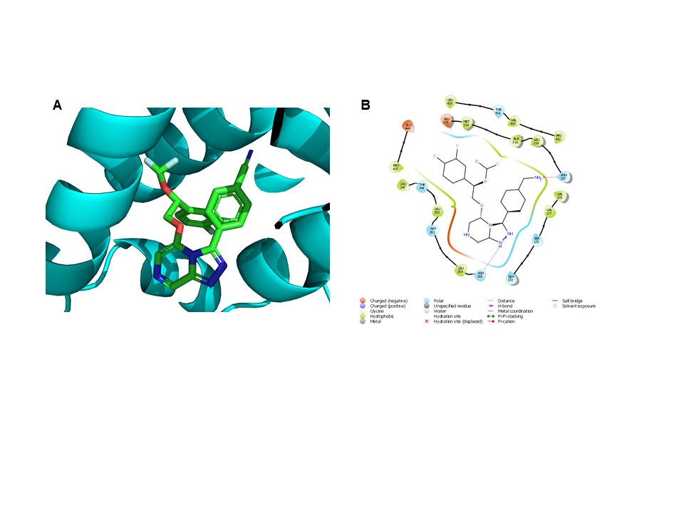

**Figure X.** A) Docked binding mode and B) binding pocket interactions of **MMV670652** with a homology model of PfATP4.

## Activity vs other life cycle stages.

Although the bloodstream stage of *Plasmodium* infection is responsible for symptomatic malaria, liver stage infection is an attractive target for the development of a prophylactic agent (Prudencio 2006, DOI: 10.1038/nrmicro1529). Liver stage potency [was evaluated](http://malaria.ourexperiment.org/triazolopyrazine_se/8912) for two compounds (**MMV669844** and **MMV670944**), which revealed low levels of activity despite high blood stage potency (**Fig. X**). The former compound was evaluated with an unknown enantiomeric composition. This compound was subsequently resolved, revealing differing blood stage potencies for the enantiomers, so it is possible that the liver stage activity arises also from one of the enantiomers ([samples available for re-evaluation?](https://github.com/OpenSourceMalaria/Series4/issues/4)). The low activity clearly distinguishes Series 4 from a structurally similar imidazopyrazine series discovered by Novartis ([discussion](https://github.com/OpenSourceMalaria/OSM_To_Do_List/issues/147); McNamara 2013, DOI: 10.1038/nature12782) that possesses activity against all liver stages in several *Plasmodium* species. The two series demonstrate no cross-resistance and are thought to possess distinct mechanisms of action (PfATP4 vs. PI4K).

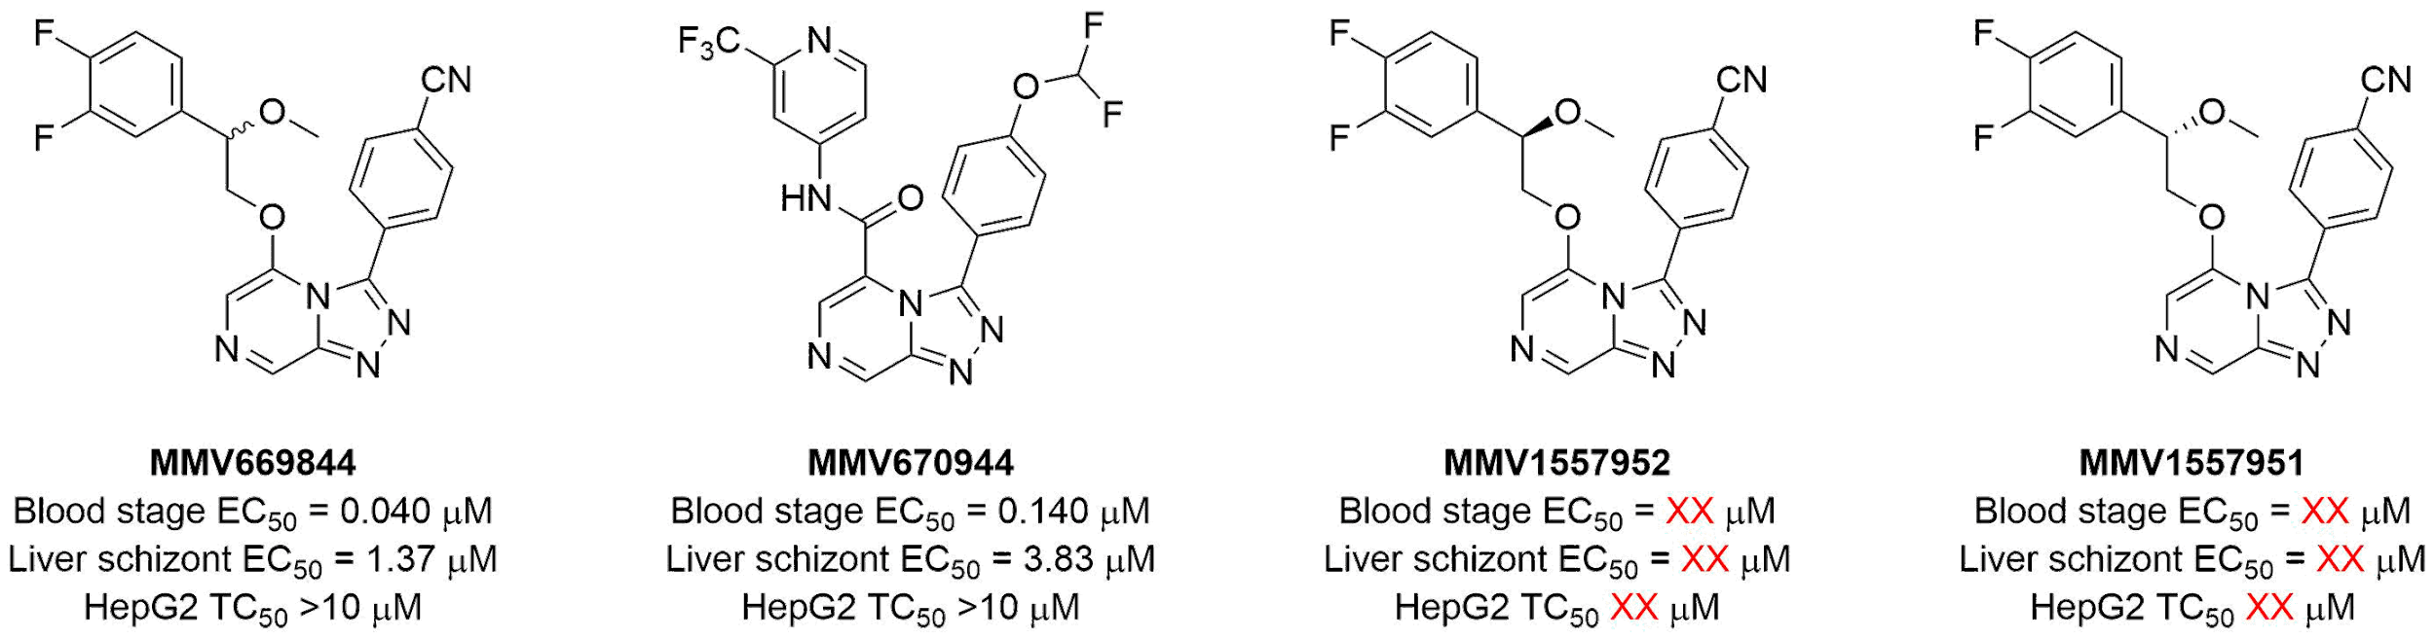

**Figure X**. Results of liver stage screening.

To complement the existing data for Series 4 *vs.* liver schizonts, OSM-S-218 and -175 were progressed into the same Pc hypnozoite assay used to evaluate the Novartis series ([data not generated/obtained?](https://github.com/OpenSourceMalaria/Series4/issues/4)).

The gametocyte life cycle stage of *Plasmodium* is responsible for mediating transmission from an infected human host to the mosquito vector (Bousema 2011, DOI: 10.1128/CMR.00051-10). Compounds that are active against gametocytes in addition to asexual life cycle stages are desirable as treatments and transmission-blocking agents. Gametocidal activity [is expected with PfATP4](https://github.com/OpenSourceMalaria/OSM_To_Do_List/issues/397) inhibitors (Spillman 2015, DOI: 10.1016/j.ijpddr.2015.07.001; Vaidya 2014, DOI: 10.1038/ncomms6521); therefore, a selection of Series 4 compounds was assessed for anti-gametocyte activity. [Data was obtained](https://github.com/OpenSourceMalaria/Series4/issues/12) showing that asexual-active active compounds have weak inhibitory activity vs male gamete formation (**Table X**).

|  |  |  |
| --- | --- | --- |
|  | **Asexual EC50 (μM)** | **Male gamete formation EC50 (μM)** |
| MMV670767 | 0.295 | 12.5 |
| MMV670246 | 7.40 | >25 |
| MMV688896 | 0.364 | 6.89 |
| MMV688895 | 4.87 | >25 |

**Table X.** Gametocyte assay results.

## Activity vs. drug resistant strains.

A representative compound (**MMV669844**) was found to exhibit unchanged potency (i.e., no cross resistance) against several drug-resistant parasite lines (Dd2, NF54, K1, 7G8, TM90C2B, Cam3.I) (GHI, [wiki](https://github.com/OpenSourceMalaria/Series4/wiki/Potency-vs.-Resistant-Strains), **Table SX**). These include resistant strains against established therapies atovaquone, chloroquine, cycloguanil, and pyrimethamine (Chugh 2015, DOI: 10.1128/AAC.03265-14) as well as clinical or preclinical candidates. The lack of cross-resistance observed in any of these strains suggests that Series 4 has a target that is distinct from that of any of the compounds mentioned above.

## 

## Evaluation against other pathogens.

Select Series 4 compounds were screened by the Community for Open Antimicrobial Drug Discovery (CO-ADD) against the ESKAPE pathogens *E. coli*, *S. aureus* (MRSA), *K. pneumoniae*, *A. baumannii*, and *P. aeruginosa* (Pendleton 2013, DOI: 10.1586/eri.13.12), and the fungi *C. neoformans* and C*. albicans*. Unfortunately, no compounds screened showed >40% growth inhibition in a single-concentration assay (32 μg/mL) against any pathogen tested (**Table SX**), indicating that this scaffold is unlikely to yield clinically useful antibacterial or antifungal agents.

# Conclusions

# 

Can we distil out the data for the top 2 or 3 compounds in a chemdraw? OHOH and BCP and another? i.e. potency, clearance, solubility.

# Methodology

## 

## Cell culture, drug incubation and metabolite extraction for metabolomics analysis.

*Plasmodium falciparum* (3D7 strain) parasites were cultured *in vitro* according to the established method (Trager 1976, DOI: 10.1126/science.781840) with minor modifications and incubated with test compounds as previously described (Creek 2016, DOI: 10.1128/AAC.01226-16). Briefly, parasites were brought to a tightly synchronous life stage population (within 4 hours of the 48 hour life cycle) by treating with 5% (w/v) sorbitol twice at an interval of 14 hours, and incubated for a further 58 hours to bring all parasites to mid-trophozoite stage (27-31 hours post infection). In 96 well plates, 200 μl cultures at 7% parasitemia and 3% haematocrit were incubated with 1 µM of test compounds for a further 5 hours (32-36 hours post infection). Each compound was incubated in four replicates and untreated controls were treated with DMSO.

After incubation with the test compounds for 5 hours, all red blood cells were settled at the bottom of the culture wells. Culture medium was carefully removed and the metabolism of the cells was quenched by placing the plate on ice and adding ice-cold phosphate buffered saline (PBS) to the culture wells. All subsequent extraction steps were performed on ice. Cells were centrifuged for 5 min at 400g in a chilled centrifuge at 4°C. The supernatant was carefully removed and 135 µl of ice-cold methanol (containing internal standards TRIS, CHAPS, CAPS and PIPES) was added followed by rapid mixing of the cell suspension using the pipette three times. Spent media samples were also prepared by adding 10 µl of the culture supernatants to 140 µl of ice-cold methanol (containing internal standards). All samples were agitated on ice for 1 hour and then centrifuged for 10 min at 1000g in a chilled centrifuge at 4°C. The supernatant was transferred to glass vials and stored at -80°C until analysis. 5 µl of each sample was combined to generate a pooled biological quality control (QC) sample to control for sample stability and instrument induced variability.

## LC-MS analysis.

Metabolite extracts were analysed using hydrophilic interaction (HILIC) liquid chromatography (LC) and high resolution mass spectrometry on an Orbitrap system as previously described (Creek 2016, DOI: 10.1128/AAC.01226-16). Eight mixtures of authentic standards containing a total of ~300 metabolites were analysed immediately before the samples to facilitate metabolite identification. Pooled QC samples were analysed at regular intervals throughout the LC-MS run and samples were randomised to avoid any impact of systematic instrument drift.

## Metabolomics data analysis.

The raw LC-MS data was processed using IDEOM as previously described (Creek 2016, DOI: 10.1128/AAC.01226-16). Manual data filtering was performed to remove peaks which were of low quality or inconsistent across replicate groups. Metabolites which matched to authentic standards in accurate mass and retention time were given a score of 8-10 in IDEOM analysis (equivalent to level 1 confidence as per the metabolomics standards initiate). Other metabolite features were annotated based on accurate mass and predicted retention time in IDEOM with a score of 5-7 (equivalent to level 2 confidence as per the metabolomics standards initiate). A total of 811 and 626 robust mass features were detected in the data from the pellet and spent media samples respectively, out of which 471 putative metabolites were identified in the former and 246 putative metabolites were identified in the latter. Peak height was used as the determinant for metabolite abundance. Univariate statistical analyses were performed using Welch’s T-test (α = 0.05) and Pearson’s correlation (MS Excel). Multivariate statistics was based on sparse Partial Least Squares Discriminant Analysis (s-PLSDA) (Le Cao 2011, DOI: https://doi.org/10.1186/1471-2105-12-253) and was performed using Metaboanalyst (Xia 2016, DOI: 10.1002/cpbi.11). Briefly, data was auto-scaled (mean-centred and divided by the standard deviation of each variable) and sparseness parameters were set to five components with ten variables per component. This allowed production of a robust and easy-to-interpret model from the high-dimensional metabolomics data. All data is deposited at Metabolomics Workbench [<http://dx.doi.org/10.21228/M8C10N> ].

## Bioinformatics and chemoinformatics.

# Acknowledgements

We thank the Medicines for Malaria Venture (MMV) and the Australian Research Council for funding. Reference PfATP4 inhibitors were provided by MMV. [Add funding sources]. HLN was supported by NSF MCB CAREER Award 1350555.

# Author Contributions

[To be inserted]

# **References**

# (assemble list below and use first name + DOI for insertion into paper text)

Ashley EA, Dhora M, Fairhurst, RM, Amaratunga C. Spread of artemisinin resistance in *Plasmodium falciparum* malaria. N Engl J Med 2014 (371) 411-423. DOI: 10.1056/NEJMoa1314981.

Baragana B et al. A novel multiple-stage antimalarial agent that inhibits protein synthesis. Nature 2015 (522) 315-320. DOI: 10.1038/nature14451.

Bousema T and Drakely C. Epidemiology and infectivity of *Plasmodium falciparum* and *Plasmodium vivax* gametocytes in relation to malaria control and elimination. Clinical Microbiology Reviews 2011 377-410. DOI: 10.1128/CMR.00051-10.

Chen T and Guestrin C. XGBoost: A scalable tree boosting system. Proceedings of the 22nd ACM SIGKDD International Conference on Knowledge Discovery and Data Mining 2016 785-794. DOI: 10.1145/2939672.2939785.

Chugh M et al. Identification and deconvolution of cross-resistance signals from antimalarial compounds using multidrug-resistant Plasmodium falciparum strains. Antimicrob Agents Chemother 2015 (59) 1110-1118. DOI: 10.1128/AAC.03265-14.

Creek DJ, Chua HH, Cobbold SA, Nijagal B, MacRae JI, Dickerman BK, Gilson PR, Ralph SA, McConville MJ. Metabolomics-based screening of the Malaria Box reveals both novel and established mechanisms of action. Antimicrob Agents Chemother 2016 (60) 6650-6663. DOI: 10.1128/AAC.01226-16.

Dharia NV et al. Use of high-density tiling microarrays to identify mutations globally and elucidate mechanisms of drug resistance in *Plasmodium falciparum*. Genome Biology 2009 (10) Article R21. DOI: 10.1186/gb-2009-10-2-r21.

Dondorp AM, Smithuis FM, Woodrow C, Seidlein LV. How to contain artemisinin- and multidrug-resistant *falciparum* malaria. Trends Parsitol 2017 (33) 353-363. DOI: 10.1016/j.pt.2017.01.004.

Jimenez-Diaz MB et al. (+)-SJ733, a clinical candidate for malaria that acts through ATP4 to induce rapid host-mediated clearance of *Plasmodium*. PNAS 2014 (111) E5455-E5462. DOI: 10.1073/pnas.1414221111.

Koes DR, Baumgartner MP, Camacho CJ. Lessons learned in empirical scoring with smina from the CSAR 2011 benchmarking exercise. J Chem Inf Model 2013 (53) 1893-1904.

Krieger E, Joo K, Lee J, Lee J, Raman S, Thompson J, Tyka M, Baker D, Karplus K. Improving physical realism, stereochemistry, and side-chain accuracy in homology modeling: Four approaches that performed well in CASP8. Proteins 2009 (77 Suppl 9) 114-122.

LaMonte et al. Mutations in the Plasmodium falciparum cyclic amine resistance locus (PfCARL) confer multidrug resistance. American Society for Microbiology 2016 (7) e00696-16. DOI: 10.1128/mBio.00696-16.

Le Cao K-A, Boitard S, Besse P. Sparse PLS discriminant analysis: Biologically relevant feature selection and graphical displays for multiclass problems. BMC Bioinformatics 2011 (12) Article 253. DOI: https://doi.org/10.1186/1471-2105-12-253.

Lehane AM, Ridgway MC, Baker E, Kirk K. Diverse chemotypes disrupt ion homeostasis in the malaria parasite. Mol Microbiol 2014 (94) 327-339. DOI: 10.1111/mmi.12765

Lim MY et al. UDP-glalactose and acetyl-CoA transporters as Plasmodium multidrug resistance genes. Nat Microbiol 2016 (19) 16166. DOI: 10.1038/nmicrobiol.2016.166.

Manach CL et al. Medicinal chemistry optimization of antiplasmodial imidazopyridazine hits from high throughput screening of a SoftFocus kinase library: Part 1. J Med Chem 2014 (57) 2789−2798. DOI: 10.1021/jm500098s.

Manach CL, et al. A novel pyrazolopyridine with *in vivo* activity in *Plasmodium berghei*- and *Plasmodium falciparum*-infected mouse models from structure−activity relationship studies around the core of recently identified antimalarial imidazopyridazines. J Med Chem 2015 (58) 8713−8722. DOI: 10.1021/acs.jmedchem.5b01605.

McNamara CW et al. Targeting *Plasmodium* PI(4)K to eliminate malaria. Nature 2013 (504) 248-253. DOI: 10.1038/nature12782.

Nilsen A et al. Quinolone-3-diarylethers: A new class of antimalarial drug. Science Translational Medicine 2013 (5) 177ra37. DOI: 10.1126/scitranslmed.3005029.

Paquet T et al. Antimalarial efficacy of MMV390048, an inhibitor of *Plasmodium* phosphatidylinositol 4-kinase. Science Translational Medicine 2017 (9) eaad9735. DOI: 10.1126/scitranslmed.aad9735.

Pendleton JN, Gorman SP, Gilmore BF. Clinical relevance of the ESKAPE pathogens. Expert Review of Anti-infective Therapy 2013 (11) 297-308. DOI: 10.1586/eri.13.12.

Phillips MA et al. A long-duration dihydroorotate dehydrogenase inhibitor (DSM265) for prevention and treatment of malaria. Science Translational Medicine 2015 (7) 296ra111. DOI: 10.1126/scitranslmed.aaa6645.

Prudencio M, Rodriguez A, Mota MM. The silent path to thousands of merozoites: The *Plasmodium* liver stage. Nat Rev Microbiol 2006 (4) 849-856. DOI: 10.1038/nrmicro1529.

Rosling JEO, Ridgway MC, Summers RL, Kirk K, Lehane AM. Biochemical characterization and chemical inhibition of PfATP4-associate Na+-ATPase activity in Plasmodium falciparum membranes. J Biol Chem 2018 (293) 13327-13337. DOI: 10.1074/jbc.RA118.003640

Spillman NJ, Allen, RJW, McNamara CW, Yeung BKS, Winzeler EA, Diagana TT, Kirk K. Na+ regulation in the malaria parasite Plasmodium falciparum involves the cation ATPase PfATP4 and is a target of the spiroindolone antimalarials. Cell Host Microbe 2013 (13) 227-237. DOI: 10.1016/j.chom.2012.12.006

Spillman NJ and Kirk K. The malaria parasite cation ATPase PfATP4 and its role in the mechanism of action of a new arsenal of antimalarial drugs. Int J Parasitol Drugs Drug Resist 2015 (5) 149-162. DOI: 10.1016/j.ijpddr.2015.07.001.

Trager W and Jensen JB. Human malaria parasites in continuous culture. Science 1976 (193) 673-675. DOI: 10.1126/science.781840.

Utter MF. Mechanism of inhibition of anaerobic glycolysis of brain by soidium ions. J Biol Chem. 1950 (185) 499-517. [www.jbc.org/content/185/2/499.citation](http://www.jbc.org/content/185/2/499.citation)

Vaidya AB et al. Pyrazoleamide compounds are potent antimalarials that target Na+ homeostasis in intraerythrocytic Plasmodium falciparum. Nat. Commun. 2014 (25) 5521. DOI: 10.1038/ncomms6521.

World Malaria Report 2017. World Health Organization 29 November 2017. Last accessed 28 August 2019. <https://www.who.int/malaria/publications/world-malaria-report-2017/en/>.

Xia J. and Wishart D.S. Using MetaboAnalyst 3.0 for comprehensive metabolomics data analysis. Curr Protoc Bioinformatics 2016 (7) 14.10.1-14.10.91. DOI: 10.1002/cpbi.11

Yap CW. PaDEL-descriptor: An open source software to calculate molecular descriptors and fingerprints. J Comput Chem 2011 (32) 1466-1474. DOI: 10.1002/jcc.21707.

As one of the key goals of the OSM Series 4 project was to improve the microsomal stability and solubility of the inherited MMV molecules, this data was obtained for a number of compounds of interest. The values for these properties were binned into “good,” “fair,” and “poor” categories in order to create a heat map, facilitating the assessment of each compound as a whole (**Table SX**).

Microsomal clearance data for core-replacement analogs is shown in **Table X**. The original triazolopyrazine core, **1**, shows moderate HLM clearance but high clearance in rat liver microsomes. Switching to cores where one of the nitrogens of the triazole has been replaced by a -CH (**2**, **3**) results in much higher HLM clearance, although the RLM clearance of **3** has been reduced significantly. A 6-substituted triazolopyrazine analog (**4**) shows low HLM but high RLM Clint.

|  |  |  |  |  |  |  |
| --- | --- | --- | --- | --- | --- | --- |
|  | | | | | | |
| **Entry** | **ID** | ***P. falciparum* EC50 (μM)** | **Clint (μL/min/mg)** | | **T1/2 (min)** | |
| **HLM** | **RLM** | **HLM** | **RLM** |
| 1 | MMV639565 | 0.038 | 16 | 70 | *nd* | *nd* |
| 2 | MMV669846 | 0.110 | 55 | *nd* | *nd* | *nd* |
| 3 | MMV670250 | 0.830 | 200 | 4.3 | >500 | <3 |
| 4 | MMV670945 | 0.034 | 8 | 100 | *nd* | *nd* |

**Table X.** Clearance of core replacement analogs. Data inherited from MMV. *nd* = no data.

A variety of amides were also assessed for metabolic stability and solubility (**Table X**). In general, these compounds showed fair to poor clearance rates in human and rat or mouse liver microsomes. Some of the most stable compounds were the difluoroinated analog **2**, and the *para*-chloro analog **7**. Insertion of an amide linker was in some cases also beneficial to solubility while maintaining potency; for example, compounds **1** and **6** had solubility >50 μM while showing activity at <1 μM concentrations.

|  |  |  |  |  |  |  |  |
| --- | --- | --- | --- | --- | --- | --- | --- |
|  | | | | | | | |
| **Entry** | **ID** | ***P. falciparum* EC50 (μM)** | **Clint (μL/min/mg)** | | **T1/2 (min)** | | **Solubility** |
| **HLM** | **RLM/**  **MLM** | **HLM** | **RLM/**  **MLM** |
| 1 | MMV668958a | 0.250 | 50 | *nd* | 20 | *nd* | 54 |
| 2 | MMV669543a | 0.276 | 11 | <14 | 86 | >120 | *nd* |
| 3 | MMV669542a | 0.180 | 72 | 290 | 13.6 | 6 | <2.5 (pH 7.4) |
| 4 | MMV669850a | 0.652 | 18 | 31 | 55 | 53 | 16.8 |
| 5 | MMV670767a | 0.191 | 22 | 64 | 45 | 27 | *nd* |
| 6 | MMV670944a | 0.140 | 20 | 16 | 52 | 105 | >200 |
| 7 | MMV670246b | 9.79 | 11 | 15 | 164 | 115 | 1.6-3.1 |
| 8 | MMV675718b | 4.19 | 114 | 166 | 15 | 10 | 12.5-25 |
| 9 | MMV675946b | 1.00 | 90 | 19 | 160 | 11 | 3.1-6.3 |
| 10 | MMV675947b | 0.970 | 201 | 360 | 9 | 5 | 3.1-6.3 |

**Table X.** Clearance and solubility data of amide analogs. aData inherited from MMV: Solubility measured at pH 6.8 in units of μM; RLM Clint. bData obtained from Monash University: Solubility measured at pH 6.5 in units of mg/mL; MLM Clint. *nd* = no data.

Finally, compounds with variation in the linker region of the 5-position substituent were evaluated as well (**Table X**). Although these compounds showed a range of metabolic stabilities when evaluated against human liver microsomes, they were uniformly highly cleared by mouse liver microsomes. [Why?] Compounds most stable to HLM clearance include the methylated compound **1**, the hydroxy compounds **9**, **12** and **13**, and the carboxylic acid **13**. Introduction of a hydroxy group on the linker also led to improved solubility, with diol **12** being one of the most soluble compounds of the series.

|  |  |  |  |  |  |  |  |
| --- | --- | --- | --- | --- | --- | --- | --- |
|  | | | | | | | |
| **Entry** | **ID** | ***P. falciparum* EC50 (μM)** | **Clint (μL/min/mg)** | | **T1/2 (min)** | | **Solubility (μg/mL)** |
| **HLM** | **MLM** | **HLM** | **MLM** |
| 1 | MMV670947 | 0.024 | 8 | *nd* | 60 | *nd* | *nd* |
| 2 | MMV672727 | 0.123 | 55 | 273 | 31 | 6 | 6.3-12.5 |
| 3 | MMV672687 | 0.070 | 38 | 170 | 45 | 10 | 12.5-25 |
| 4 | MMV672723 | 0.101 | 37 | 94 | 47 | 18 | 12.5-25 |
| 5 | MMV670438 | 0.483 | 33 | 60 | 53 | 14 | 12.5-25 |
| 6 | MMV671651 | 0.279 | 41 | 77 | 42 | 23 | 6.3-12.5 |
| 7 | MMV897763 | 0.190 | 264 | 478 | 7 | 4 | 6.3-12.5 |
| 8 | MMV897698 | 0.362 | 66 | 262 | 26 | 7 | 6.3-12.5 |
| 9 | MMV688896 | 0.360 | 7 | 278 | 246 | 6 | 25-50 |
| 10 | MMV693155 | 0.134 | 24 | 121 | 73 | 14 | 12.5-25 |
| 11 | MMV1579336 | 3.88 | <7 | <7 | >255 | >255 | 25-50 |
| 12 | MMV1581295 | ??? | 15 | 42 | 116 | 41 | 50-100 |
| 13 | MMV897708 | 0.800 | 10 | 64 | 177 | 27 | 25-50 |
| 14 | MMV897709 | 0.150 | 47 | 159 | 37 | 11 | 12.5-25 |
| 15 | MMV670652a | 0.017 | <8 | 30 | *nd* | *nd* | *nd* |
| 16 | MMV897707 | >10 | 104 | 213 | 17 | 8 | 12.5-25 |

**Table X.** Clearance and solubility data of selected analogs. Solubility measured at pH 6.5. aData inherited from MMV; RLM Clint measured instead of MLM. *nd* = no data.